A Century of Heaven on Earth

Premiere of the first projection planetarium exactly 100 years ago in the Deutsches Museum: On 21 October, there will be celebrations in Munich and Jena.

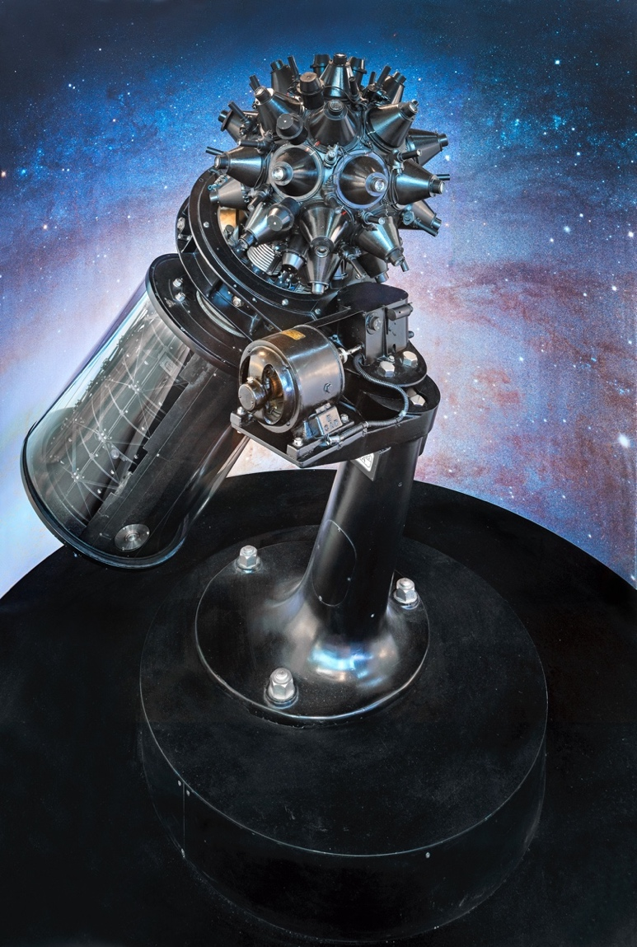
(Munich/Jena, 18 October 2023) Exactly 100 years ago, on 21 October 1923, the world’s first public demonstration of a projection planetarium took place at the Deutsches Museum. The star projector, a completely new technical masterpiece at the time, had been developed on the initiative of museum founder Oskar von Miller in collaboration with the Zeiss company. The great anniversary is now being celebrated at parallel ceremonies with high-ranking guests and two fulldome film premieres in Munich and in Jena. At the same time, these are the prelude to numerous projects planned by the International Planetarium Society (IPS) and the Gesellschaft Deutschsprachiger Planetarien e. V. (GDP) with the support of the Carl Zeiss Foundation to mark the centenary. And the special exhibition “100 Years of the Planetarium”, including regular star shows, will be on display in the entrance hall of the Deutsches Museum until 28 January 2024.

“In the astronomy department, the Ptolemaic Planetarium donated by Zeiß in Jena, the demonstration of which was undertaken by the ingenious designer Dr. Bauersfeld himself, aroused amazement.” These brief sentences in the administration report on the year 1923 state the planetarium premiere during a tour of the new museum building.
The first star projector: the Zeiss Modell I in the Deutsches Museum.
Photo: Deutsches Museum

A few pages earlier, Oskar von Miller finds much more euphoric words for the new additions: “The most valuable, however, are 2 large planetariums, the likes of which have never existed in the world before. The Ptolemaic planetarium lets the visitor immediately observe the movement of the sun, moon and planets between the fixed stars clearly, whereas in earlier centuries scholars like Ptolemy, Tycho de Brahe, had to laboriously calculate the hardly visible movements. This planetarium is a marvel, just like the old clocks in Strasbourg, etc. The director of the Zeißwerke, Dr.-lng. Bauersfeld, sacrificed days and nights to construct the ingenious mechanism, which took 5 years to complete.”

The great enthusiasm of the museum’s founder is hardly surprising, since the idea for the two planetariums came from himself. “The astronomy department was very important to Oskar von Miller for his new museum,” says Christian Sicka, curator of astronomy at the Deutsches Museum. The museum founder wanted to present the history of the development of this natural science as comprehensively as possible with historical originals. To this end, demonstrations were to make the subject matter comprehensible to a broad section of the population. “And for the explanation of the fixed stars and the solar system, von Miller wanted to create something unprecedented,” says Sicka. This initially earned the museum man a rebuff when he first approached the Carl Zeiss company in Jena in July 1913 about building a planetarium.

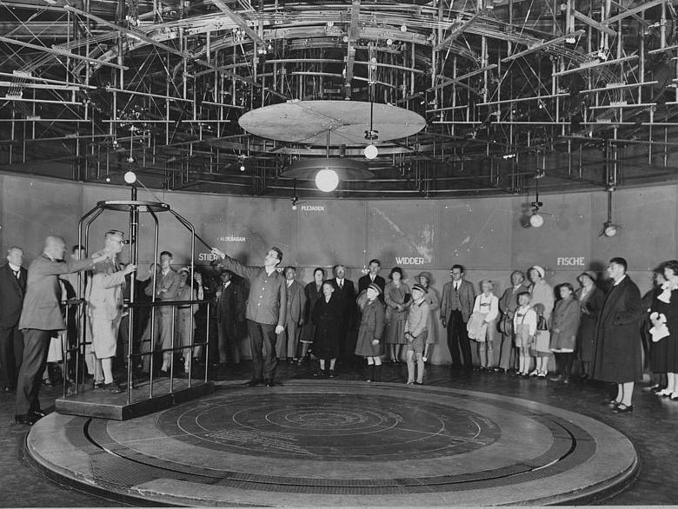
Three months later, Zeiss accepted the order from Munich after all - even for two planetariums that were to bring the sky down to earth from different perspectives. In the Copernican one travelled on an “earth carriage” around the central sun and looked into the orbital plane of the planets (see photo right). At the Ptolemaic one experienced the projection of an artificial starry sky onto a dome above the shadow silhouette of Munich - something that had never been seen before anywhere in the world. However, it still took ten years after the Zeiss promise at the time until the public premiere of the first star projector - also due to delays caused by the First World War.

On 21 October 1923, the Zeiss Model I was first demonstrated to the museum committee during a tour of the museum construction site, as mentioned above. Afterwards, the projector ran in public operation in the still unfinished dome on the Museum Island for six weeks. At the end of December, the device went back to Jena. Because of the huge success with the Munich public, the Zeiss company offered public demonstrations on the roof of the factory in Jena from August to October 1924. And after the opening of the Deutsches Museum on 7 May 1925, when the planetarium then went into regular operation, the new projector technology set off on a triumphal march from Germany across the globe.

There are now about 4000 planetariums worldwide. They offer education, culture and entertainment, they show and explain the universe and our place in it and fascinate and delight their audiences. “Every year, around 100 million people still go to a planetarium,” says curator Christian Sicka. “Despite the internet and virtual reality, the experience under the dome simply remains something very special.”

The 100th anniversary of this still so captivating invention is now being celebrated at two parallel ceremonies on 21 October in Munich and in Jena. The list of speakers includes astrophysicist and astronaut-to-be Suzanna Randall and former space traveller Thomas Reiter. In addition, two fulldome premieres will be shown during the event. You can follow the event in a livestream on the official anniversary page. The event also marks the launch of numerous projects planned by the International Planetarium Society (IPS) and the Gesellschaft Deutschsprachiger Planetarien e. V. (GDP) with the support of the Carl Zeiss Foundation between 21 October 2023 and 7 May 2025 together with planetariums around the world to celebrate the centenary. The patron for the anniversary is Federal President Frank-Walter Steinmeier.

In addition, the special exhibition “100 Years of the Planetarium” with unique exhibits ranging from 16th century astrolabes and celestial globes to armillary spheres and a specially built planetarium dome can be seen and experienced at the Deutsches Museum until 28 January 2024. Admission to the regular star shows under the ten-metre dome costs 5 euros (museum members free), tickets are available at the information desk in the entrance hall.

The Planetariums in the Deutsches Museum

From the first star projector to the most modern fulldome technology

1912: Oskar von Miller formulates his idea for two planetariums: In the Ptolemaic (geocentric) Planetarium, the public should be able to observe the processes in the night sky in fast motion, as they are observed in nature. In the Copernican (heliocentric) Planetarium, visitors should be able to recognise the processes from the perspective of the moving earth. At the end of a ten-year development together with the engineers of the Zeiss company, both planetariums have been realised: The geocentric projection planetarium and a heliocentric planetarium, where you can travel around the sun as the centre in an earth carriage.

21 October 1923: Walther Bauersfeld demonstrates the function of the projection planetarium in the not yet completed collection building of the Deutsches Museum with the new type of star projector before the museum committee.

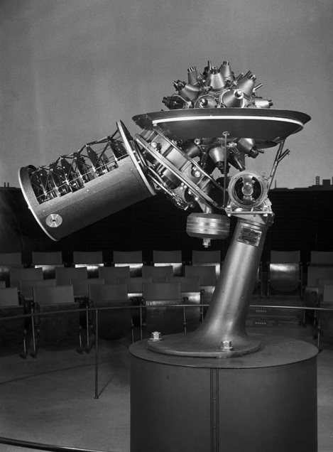
End of 1923: The star projector (photo right) is brought back to Jena for final completion. Until the public premiere in Munich, demonstrations take place in a temporary planetarium dome on the roof of the Zeiss factory.

October 1924: The Copernican Planetarium is demonstrated for the first time to the Museum Committee.

7 May 1925: The planetarium is ceremoniously opened to mark the inauguration of the new collection building on Museum Island. The diameter of the planetarium dome is nine metres. Seating is not provided.

1944: After heavy fire and explosive bomb hits, the operation of the planetariums is discontinued and the Zeiss projector is moved out of storage. The museum remains closed until October 1947.

1951: Operations are resumed with the old planetarium projector in a temporary plaster dome in the Physics Department on the 1st floor of the Deutsches Museum.

1954: The remaining parts of the Copernican Planetarium are removed from the room, which was badly damaged during the war, and stored in the depot.

1956: The projection planetarium is moved to the central dome, directly above the original 1925 location. The diameter of the dome is now 16 metres. Seating is installed in the auditorium for the first time.

1960: With the division of Germany after 1945, a new Zeiss factory is built in Oberkochen. In 1956, the Model IV is developed there. In 1960, the new model is installed in the Deutsches Museum.

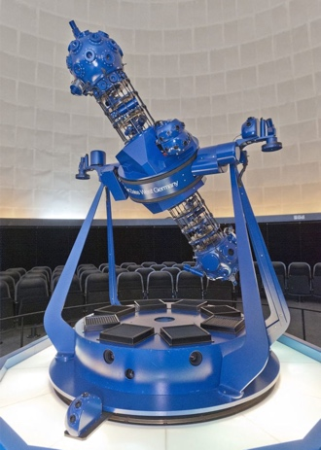
1988: Modernisation takes place with the more manageable M 1015 projector (photo right) from Zeiss in Oberkochen, which is specially designed for small to medium-sized planetarium domes.

1993: A second planetarium is opened on the Museum Island in the privatised Forum der Technik next to the Collection Building. A large planetarium with a 20-m dome diameter and the Zeiss Model VII star projector. It is the only planetarium projector that contains components from both Zeiss in Oberkochen and Zeiss in Jena. In 2005, the planetarium has to close due to insolvency.

2015: The planetarium in the astronomy exhibition gets a new dome and is equipped with the Skymaster ZKP 4 star projector and a digital 4K full-dome projection system from Zeiss in Jena. In 2022, the planetarium has to close temporarily for renovation of the building section.

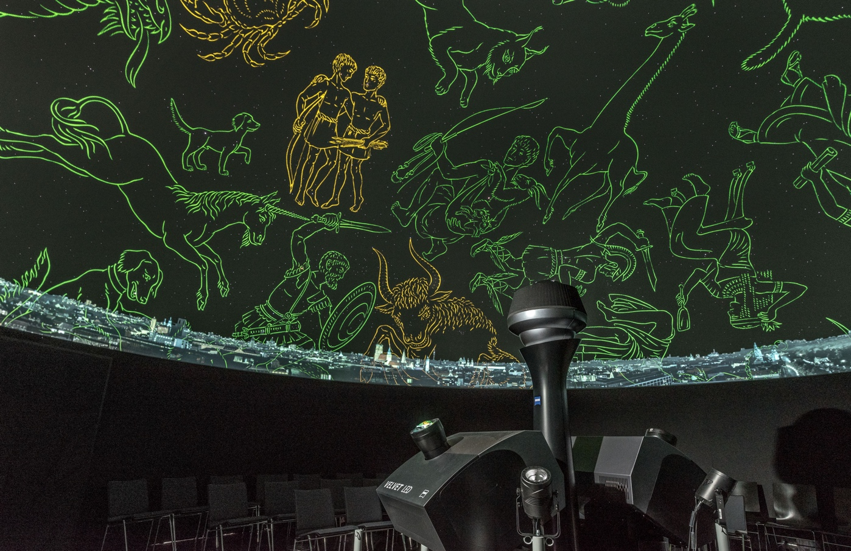

2023: The special exhibition “100 Years of the Planetarium” opens. In the mobile dome, an ASTERION star projector provides the starry sky and two VELVET video projectors for fulldome projection (photo above).

Media download: www.deutsches-museum.de/museum/presse

Contact:
Gerrit Faust,
Head of Public Relations Deutsches Museum
Tel. ++49 89 2179 - 281
Email: presse@deutsches-museum.de

